***Friction game ideas:***

Feedback taken from Rob and Chris, make the player tap on the screen in front of the object they have to move. Have one or two people in front of object with brooms moving the player’s object in a desired direction. Game is still in a top down perspective.

Player can change direction by tapping more rapidly in a certain direction, so for example if player taps on left part of their screen the object will gradually veer to left.

To encourage players to move their objects left to right obstacles can be found on course such as rocks or tees in the way.

Power ups can be found on the course as the player is moving along, player must tap on the power up to collect it and activate it. These powerups can be things such as automatic dodging from obstacles or a speed boost. (Playtesting required).

Can be a racing game or a endless runner where players must continue dodging and moving until one player gets eliminated.

Example of a curling game for reference:

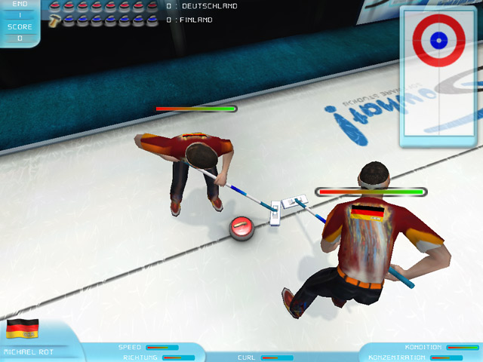

Big Fish Games. (n.d.). *Curling for iPad, iPhone, Android, Mac &amp*. [online] Available at: http://www.bigfishgames.com/games/2301/curling/ [Accessed 2 Feb. 2017].